COUNCIL ASSESSMENT REPORT

|  |  |  |
| --- | --- | --- |
| **Panel Reference** | PPSNTH-59 | |
| **DA Number** | 5.2020.247.1 | |
| **LGA** | Lismore | |
| **Proposed Development** | Alterations and additions to a recreational facility (major) comprising the upgrading of two grandstands (Gordon and Crozier Pavilions), and a new Oakes Oval Grandstand. | |
| **Street Address** | 144 Magellan Street Lismore | |
| **Applicant/Owner** | Lismore City Council | |
| **Date of DA lodgement** | 12 May 2020 | |
| **Total number of Submissions**  **Number of Unique Objections** | * 1 * 1 | |
| **Recommendation** | Approval | |
| **Regional Development Criteria (Schedule 7 of the SEPP (State and Regional Development) 2011** | 3. Council related development over $5 million | |
| **List of all relevant s4.15(1)(a) matters** | * State Environmental Planning Policy (State and Regional Development) * State Environmental Planning Policy (Infrastructure) 2007 * State Environmental Planning Policy 55 – Remediation of Land * Lismore Local Environmental Plan 2012 * Lismore Development Control Plan   Part A  Chapter 7 – Off Street Carparking  Chapter 8 – Flood Prone Lands  Chapter 9 – Signage  Chapter 13 – Crime Prevention through Environmental Design  Chapter 15 – Waste management Plan  Chapter 22 – Water Sensitive Design | |
| **List all documents submitted with this report for the Panel’s consideration** | * Attachment 1 - Draft Conditions of Consent * Attachment 2 - Propose Plan Set * Attachment 3 - Council Referral Officers Reports * Attachment 4 - External Referral Responses | |
| **Clause 4.6 requests** | * None requested/required. | |
| **Summary of key submissions** | * The need for the development has not been substantiated and therefore not in the public interest | |
| **Report prepared by** | Craig Bradridge | |
| **Report date** | 10 February 2021 | |
| **Summary of s4.15 matters**  Have all recommendations in relation to relevant s4.15 matters been summarised in the Executive Summary of the assessment report? | | **Yes** | |
| **Legislative clauses requiring consent authority satisfaction**  Have relevant clauses in all applicable environmental planning instruments where the consent authority must be satisfied about a particular matter been listed, and relevant recommendations summarized, in the Executive Summary of the assessment report?  *e.g. Clause 7 of SEPP 55 - Remediation of Land, Clause 4.6(4) of the relevant LEP* | | **Yes** | |
| **Clause 4.6 Exceptions to development standards**  If a written request for a contravention to a development standard (clause 4.6 of the LEP) has been received, has it been attached to the assessment report? | | **Not applicable** | |
| **Special Infrastructure Contributions**  Does the DA require Special Infrastructure Contributions conditions (S7.24)?  *Note: Certain DAs in the Western Sydney Growth Areas Special Contributions Area may require specific Special Infrastructure Contributions (SIC) conditions* | | **No** | |
| **Conditions**  Have draft conditions been provided to the applicant for comment?  *Note: in order to reduce delays in determinations, the Panel prefer that draft conditions, notwithstanding Council’s recommendation, be provided to the applicant to enable any comments to be considered as part of the assessment report* | | **Yes** | |

**DEVELOPMENT ASSESSMENT REPORT**

**ADDRESS/LOCALITY**: Lot 1 DP 709802, 144 Magellan Street Lismore

**APPLICATION No:** 5.2020.247.1

**PROPOSAL:** Alterations and additions at Lot 1 DP 709802, 144 Magellan Street Lismore (Oakes Oval and Crozier Field) comprising:

* + - * 1. alterations and additions to the Crozier Field Grandstand including new concrete concourse (viewing deck), stairwell, lift and players access tunnel, media and broadcasting facilities, function rooms, food and drink outlets, storage and access facilities.
        2. alterations and additions to Gordon Pavilion (Oakes Oval), including new roof for new north and south stairs, refurbishment of the lounge to be used for functions, new media / corporate and coaches’ boxes and broadcasting facilities, function spaces, food and drink outlets, amenities, meeting and storage spaces and accessibility facilities;
        3. a new 140 seat prefabricated grandstand for Oakes Oval;

**OWNER**: Lismore City Council

**APPLICANT**: Lismore City Council

**AUTHOR**: Mr C Bradridge

**DATE OF REPORT**: 5/02/2021

**DATE LODGED**: 30/06/2020

**AMENDED**: 14/10/2020 - as per clause 55(2) of the *Environmental Planning and Assessment Regulation 2000*.

**SUMMARY**

**ISSUES/VARIATIONS**: Car parking, noise and impacts to residential amenity, flood

**SUBMISSIONS**: One

**RECOMMENDATION**: Approval

**1 Executive summary**

In this report the proposal has been assessed against all relevant Section 4.15 matters of the *Environmental Planning and Assessment Act 1979*. The proposed development satisfies all relevant heads of consideration under S4.15. A detailed assessment is in Section 10 of this report with a summary as follows.

The proposal relates to grandstand works and construction of a multi-use building within an existing recreation facility (major). The works are being proposed and undertaken by (or on behalf of) Lismore City Council and has a capital investment value (CIV) of more than $5 million. Accordingly, the proposal is declared to be Regionally Significant Development under Schedule 7 of the*State Environmental Planning Policy (State and Regional Development)* and to be determined by the Northern Regional Planning Panel pursuant to clause 4.5(a) of the *Environmental and Assessment Act 1979*.

Clause 7 of *State Environmental Planning Policy 55 – Remediation of Land* provides that a consent authority must not consent to the carrying out of any development on land unless it has considered whether the land is contaminated. Council has considered whether the land is contaminated and is satisfied the proposed development complies with this SEPP.

In accordance with Clause 101 of the *State Environmental Planning Policy (Infrastructure) 2007* (ISEPP) the Consent Authority is to have consideration for the safety, efficiency and ongoing operation of the classified road. Dawson Street is a classified (Regional) Road (MR 65). Council considers that the safety, efficiency and ongoing operation of this road is satisfactory in relation to the proposed development.

*State Environmental Planning Policy (Koala Habitat Protection) 2020* requires Council to consider whether the development will impact on koala habitat. Council is satisfied that the development will not impact on potential or preferred Koala Habitat.

The proposed development is not on land included on the Biodiversity Values Map and does not involve clearing of native vegetation in excess of the area clearing threshold. The proposed development is not likely to significantly affect threatened species or ecological communities, or their habitats, and is not in a declared area of outstanding biodiversity value. A test under section 7.3 of the *Biodiversity Conservation Act 2016* has been conducted as per assessment requirement.

*State Environmental Planning Policy (Vegetation in Non-Rural Areas) 2017* applies to land zoned RE1 Public Recreation. Tree removal at the site is being considered under a separate environmental assessment (works permitted without consent SEPP (Infrastructure) 2007) and planning approval pathway. Notwithstanding, Council is satisfied that the impact of the proposed tree removal is minor, with similar species being common and well represented in the broader landscape.

The proposed development is permissible as a recreation facility (major) within the RE1 Public Recreation zone under the provisions of the *Lismore Local Environmental Plan 2012 (LLEP 2012)*. The subject development is consistent with the objectives of the zone and the objectives of the controls and complies with applicable development standards.

Relevant clauses in LLEP 2012 where the consent authority must be satisfied are as follows; Clause 6.3(3) Flood planning, clause 6.4(4) Drinking water catchments and clause 6.9 Essential services. Council is satisfied that the proposed development complies with these clauses.

The application has been assessed against the relevant controls in the *Lismore Development Control Plan* notably, *Chapter 2 Commercial Development*, *Chapter 8 Flood Prone Lands, Chapter 13 Crime Prevention through Environmental Design* and *Chapter 22 Water Sensitive Design* of which the proposal complies.

With no car parking existing or proposed on the site the development does not comply with Schedule 1 of *Lismore Development Control Plan – Part A*, *Chapter 7 Off Street* *Carparking.* Conditions surrounding the management of car parking has been addressed to the satisfaction of Council with further discussion on this matter found under Section *11.4 Traffic generation and car parking provision* in this report.

Clause 94 of *Environmental Planning & Assessment Regulation* 2000 *(EPA Regulation 2000)*, requires the consent authority to take into consideration whether it would be appropriate to require the existing building(s) to be brought into total or partial conformity with the *Building Code of Australia* (BCA). Assessment of the proposal has identified that the existing buildings can be bought into partial conformity with the Building Code of Australia.

The *EPA Regulation 2000* requires that Council take into consideration *AS 2601-1991: the demolition of structures*. As demolition of some structures on the site is proposed to occur, a suitable condition has been imposed.

All likely impacts of the proposed development have been considered including environmental impacts on both the natural and built environments, and social and economic impacts in the locality and are to the satisfaction of Council.

The application was notified in accordance with the regulations and Council’s Community Consultation Plan with one submission received. The site is considered suitable for the proposed development and is in the public interest.

**2 Background**

The *Lismore Park Plan of Management* and *Lismore Parklands Master Plan* was presented to Council at the 12 May 2020 Council meeting and adopted 11 August 2020. The Master Plan was prepared in consultation with Lismore residents and other key stakeholders and contains specific recommendations for the progressive updating of facilities throughout the subject site to meet national sporting requirements. The proposed development is a realisation of the adopted plan and a component of the progressive updating of facilities. The enhancement of Lismore parklands has been a long-term objective of the strategic vision for the development of Lismore City.

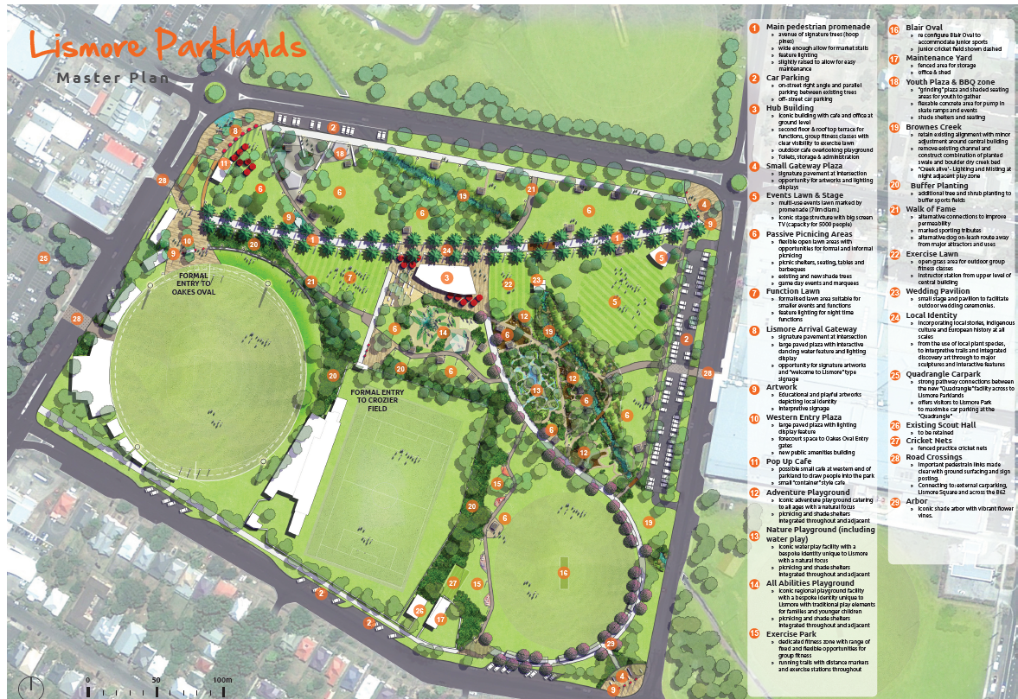

**Figure 1 – Lismore Park Master Plan**

The subject Development Application (DA) 2020/247 was submitted 15 May 2020, for alterations and additions to the grandstand facilities at the Oakes Oval and Crozier Field Lismore. The application was amended 14 October 2020 pursuant to clause 55(2) of the *Environmental Planning and Assessment Regulation 2000* to include further proposed works namely a function room and broadcasting and media facilities within the Crozier Pavilion.

The application was notified to adjoining and surrounding property owners and advertised in *Lismore Local Matters* in accordance with the provisions of *Lismore City Council’s* *Community Consultation Plan*. This was done on two occasions to coincide with the amended changes. One submission was received as a result of the exhibition period(s).

**2.1 Development History**

The subject site has a number of DA’s that have contributed to the existing recreational facility. Additional works have been undertaken by Council under the provisions of cl 65 of *State Environmental Planning Policy (Infrastructure) 2007,* development permitted without consent.

A table of development applications submitted is provided overleaf.

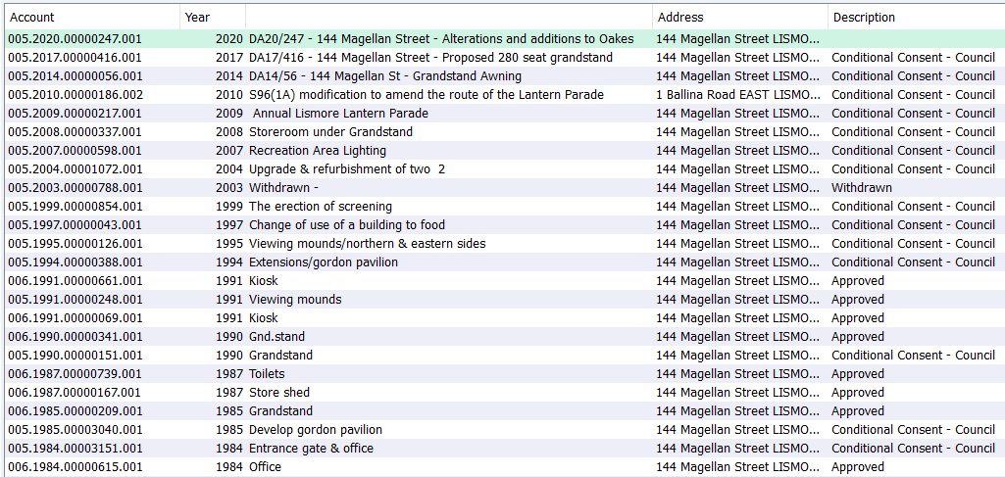

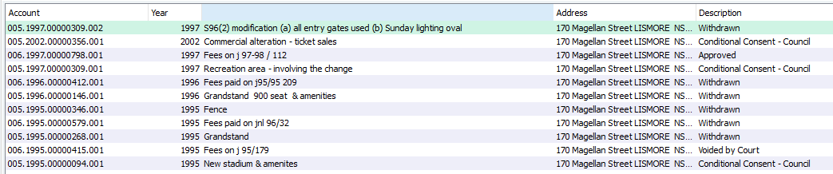

**Table 1 – Development application history for the subject site**

Developmentconsent 97/309 has been requested to be surrendered because of conflicts in operational, and construction requirements under this consent.

**3 Description of Proposal**

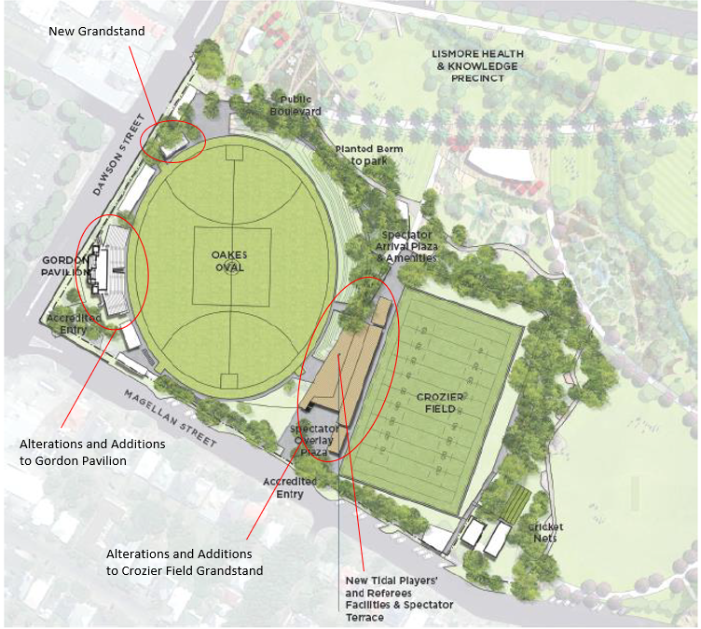

**Figure 2 – Oakes Oval and Crozier Field Master Plan**

Development Application 2020/247 seeks consent for alterations and additions to an existing recreation facility (major) located at Lot 1 DP 709802, 144 Magellan Street Lismore. The proposed development comprises of a new grandstand and alterations and additions to two existing grandstands known as the Gordon Pavilion and the Crozier Field Grandstand.

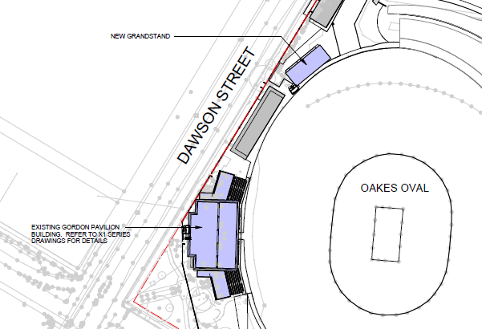

**Figure 3 – Proposed works for Oaks Oval**

Proposed works for Oaks Oval include A new 140 seat grandstand and alterations and additions to the existing Gordon Pavilion comprising of a new roof for new north and south stairs, media / corporate and coaches’ boxes, media and broadcasting facilities, function spaces, food and drink outlets, amenities, meeting and storage spaces and accessibility facilities.

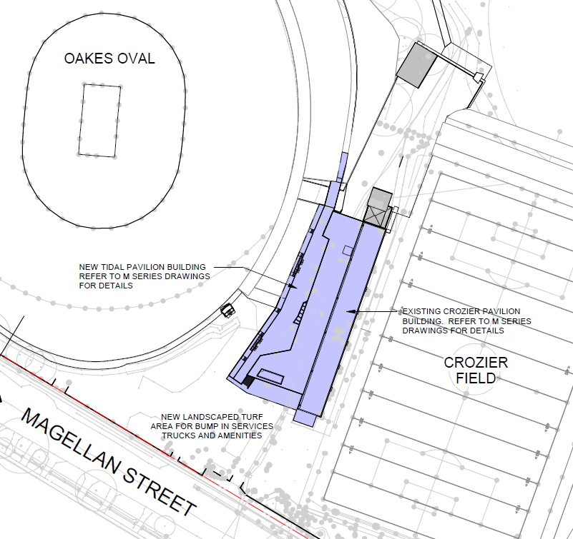

**Figure 4 – Proposed Tidal Pavilion Building**

Proposed works for Crozier Field include the erection of a new multi-use building (which is referred to as a *Tidal Pavilion Building* in the submitted plans and accompanying documents, see Figure 4 above). This proposed addition is located between Oakes Oval and Crozier Field and to be attached to the existing Crozier Field Grandstand. The building is proposed to contain a range of medical facility spaces, player and official change rooms, amenities, meeting rooms and a viewing deck for Oakes Oval. A concrete concourse is proposed a with stairwell, lift and players access tunnel to Crozier Field and Oakes Oval.

Alterations to the Crozier Field Grandstand include the removal of the ground floor amenities and change rooms, the removal of the media box to allow for the construction of additional seating. Proposed additions also include; new change rooms, new seating platform and seats to replace former media box fronting Crozier Field, new bathroom facilities, new corporate and coaches’ offices, new communications room function space and canteen.

The proposed works are identified in *Attachment 2 – Proposed Plan Set*.

**4 Description of Locality**

The site is located on the western fringe of the Lismore Central Business District (CDB) and is bordered by Magellan Street to the south and Dawson Street to the west. The northern and eastern adjacent uses are a series of sporting fields (known as Lismore Park) which are then bounded by Uralba Street to the north and Brewster Street to the east. There is a strip of low density residential development located opposite the site along Magellan Street which is bounded by the sports ground to the north and commercially zoned land to the south and west.

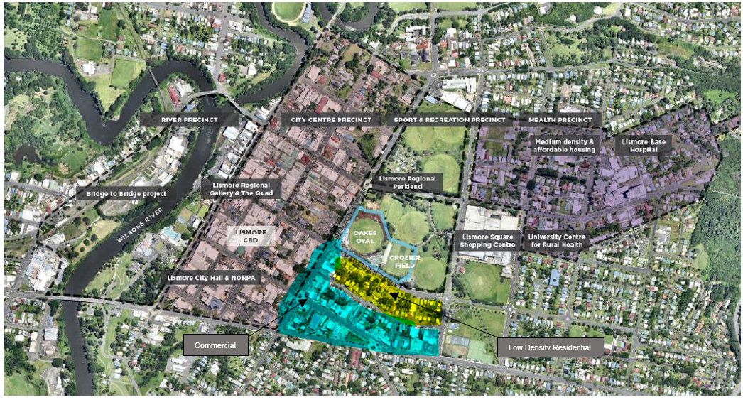

**Figure 5 – Locality map**

**5 The site**

The subject site is approximately 13 hectares in size and predominately flat. Oakes Oval is grass field supporting primarily Australian rules and cricket and located in the west of the site. Crozier Field is a rectangular grass field primarily supporting soccer, rugby league and union. Grandstand facilities and players amenities sit on the western side of each field and known as either Gordon Pavilion (Oakes Oval) or Crozier Field Grandstand (Crozier Field).

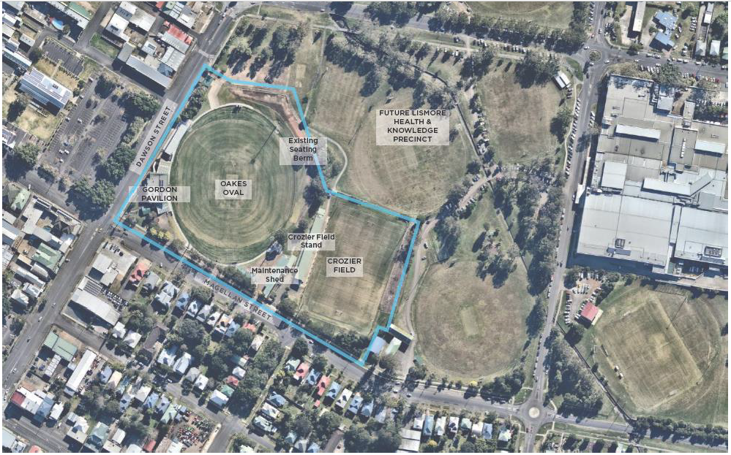

**Figure 6 – The site**

Other existing facilities at the site include a small entry plaza off Dawson Street, public amenities, ticket gates, maintenance sheds and seating berms. Within and around the Gordon Pavilion are 1,500 viewing seats, plus an additional modular / metal grandstand, a kiosk, player official facilities, a function space, bar, kitchen and amenities. Within and around the Crozier Field Grandstand are 900 viewing seats, public, player and official amenities, kiosk and broadcast booth.

**6 Statutory Controls**

State Environmental Planning Policy (State and Regional Development)

State Environmental Planning Policy (Infrastructure) 2007

State Environmental Planning Policy 55 – Remediation of Land

Lismore Local Environmental Plan 2012

* Zoning – RE1 Public Recreation
* Item of Heritage – No
* In vicinity of Heritage Item – Lismore Regional Gallery, 110 Magellan Street 100m, TAFE College, 64 Conway Street – 130 m
* Heritage Conservation Area – No

Lismore City Section 94 Contributions Plan

**7 Policy Controls**

Lismore Development Control Plan

Part A

Chapter 7 – Off Street Carparking

Chapter 8 – Flood Prone Lands

Chapter 9 – Signage

Chapter 13 – Crime Prevention through Environmental Design

Chapter 15 – Waste management Plan

Chapter 22 – Water Sensitive Design

Community Consultation Plan – *Appendix 1 (Council’s Community Engagement Strategy and Community Participation Plan)*

1.4.7 1.8.5 Undergrounding of Power Lines - CBD

1.8.6 Undergrounding of Telephone Plant in Subdivisions

2.1.3 Fire Safety of Buildings

**8 Internal Referrals**

Set out below is a summary of each of the relevant referral officer’s comments. A full copy of each

of the referral comment reports (where relevant) are included in *Attachment 3 - Council Referral Officers Reports***.**

**8.1 Building**

The application has been reviewed and comments provided, with no objections raised subject to the imposition of appropriate conditions that are included in the draft conditions attached to this report. The issues addressed within the referral comments from this officer include BCA requirements, fire safety measures and access for people with a disability.

**8.2 Environmental Health**

The application has been reviewed and comments provided, with no objections raised subject to the imposition of appropriate conditions that are included in the draft conditions attached to this report. The issues addressed within the referral comments from this officer include potential noise impacts and land contamination and stormwater treatment.

Notably, a condition is also provided that requires the development to be supported by, and operated in accordance with, a site-specific Operational Management Plan (OMP). Further comment surrounding the OMP is found in Section *11.3 Noise and amenity* of this report.

**8.3 Water and Sewer**

The application has been reviewed and comments provided, with no objections raised subject to the imposition of appropriate conditions that are included in the draft conditions attached to this report.

The issues addressed include a discussion on applicable Section 64 levies which have been further discussed in section *10.8.1 Levies - Section 64 of the Local Government Act 1993* in this report. Services such as water and sewer capacity have been identified as adequate.

**8.4 Engineering/Traffic/Stormwater Drainage**

The application has been reviewed and comments provided, with no objections raised subject to the imposition of appropriate conditions that are included in the draft conditions attached to this report.

The issues addressed within the referral comments from this officer include vehicular access and traffic impact, parking, stormwater and flood.

**9** **External Referrals**

Set out below is a summary of the external referrals. A full copy of each response from the external

referral bodies are included in *Attachment 4 – External Referral Responses.*

**9.1 Transport for NSW (Infrastructure SEPP)**

Transport for NSW (TfNSW) is given the opportunity under Clause 104 to comment on traffic generating developments listed under Schedule 3 of the SEPP of which the proposed development is scheduled.

The application was referred to TfNSW and comments were received on 3 December 2020. TfNSW raised no objections to the proposed development and supports the development of a Traffic Management Plan for all large events which is a proposed condition of consent.

**9.2 Local Traffic Committee**

The Local Traffic Committee reviewed the application and provided recommendations on works to be done on the surrounding road network (Dawson and Magellan Streets) including line marking that are to be incorporated into the development as proposed conditions of consent.

**9.3 NSW Police**

The application was referred to NSW Police, comments with recommendations were provided 1 September 2020. NSW Police did not have any objections to the proposed development but recommend the following:

* Implementation of quality CCTV system throughout the facility with coverage of all entry/exit points.
* Implementation of security lighting – to improve overnight visibility and surveillance opportunities.
* Clearly marked entry/exit points – wayfinding signage should be clearly visible.
* Installation of improved security fencing and gates.
* Fields to be closed during daylight hours when not in use for organised sporting events/training.
* Maintenance of perimeter trees/shrubs to improve visibility from the surrounding streets.

These recommendations have been incorporated as proposed conditions of consent.

**10 Consideration**

The relevant matters for consideration under Section 4.15 of the *Environmental Planning and Assessment Act 1979*, are assessed under the following headings:

**10.1 Biodiversity Conservation Act 2016**

The proposed development is not on land included on the Biodiversity Values Map and does not involve clearing of native vegetation in excess of the area clearing threshold. The proposed development is not likely to significantly affect threatened species or ecological communities, or their habitats, and is not in a declared area of outstanding biodiversity value. A Biodiversity Development Assessment Report is therefore not required to be submitted.

The test under section 7.3 of the *Biodiversity Conservation Act 2016* has been conducted and the proposal does not trigger the offset scheme threshold.

**10.2 State Environmental Planning Policy (State and Regional Development)**

The works are being proposed and undertaken by (or on behalf of) Lismore City Council and have a capital investment value (CIV) of more than $5 million. Accordingly, the proposal is declared to be Regionally Significant Development under Schedule 7 of the*State Environmental Planning Policy (State and Regional Development)* and to be determined by the Northern Regional Planning Panel pursuant to clause 4.5(a) of the *Environmental and Assessment Act 1979*.

**10.3 State Environmental Planning Policy (Koala Habitat Protection) 2020**

The site is over 1ha in area, and there may be potential koala habitat on the site. The development will not disturb any areas of potential koala habitat. Further investigation into core koala habitat, or an individual koala plan of management, is not required for this development under the terms of SEPP 44.

**10.4 State Environmental Planning Policy (Vegetation in Non-Rural Areas) 2017**

*State Environmental Planning Policy (Vegetation in Non-Rural Areas) 2017* applies to land zoned RE1 Public Recreation. The SEPP regulates clearing of native vegetation below the Biodiversity Offset Scheme (BOS) threshold where a proponent will require an approval from the Native Vegetation Panel established under the *Local Land Services Amendment Act 2016* and vegetation below the BOS threshold where a proponent will require a permit from Council, if that vegetation is identified in the Council’s Development Control Plan (DCP).

Tree removal at the site is being considered under a separate environmental assessment (works permitted without consent SEPP (Infrastructure) 2007) and planning approval pathway; however, considering tree removal will facilitate some of the proposed works under this DA, consideration has been made to potential impacts.

Council is satisfied that the impact to vegetation is minor, with similar species being common and well represented in the broader landscape. The loss of these trees within the urban landscape will be significantly offset through landscaping proposed at the site (separate to this DA).

**10.5 SEPP 55 & Contaminated Land Management Issues**

In recognition of the commentary provided within the SEE, and that site management of excavated soil will follow an unidentified findings protocol, Council’s Environmental Health Officer is satisfied that the development is compliant in terms of SEPP 55 & contaminated land management issues.

The recommendation that all waste materials generated from demolition activities are managed in accordance with a *Hazardous Materials Management Plan* is also supported.

**10.6 SEPP 64 – Advertising and Signage**

No signage is proposed under this DA, a standard condition of consent has been applied.

**10.7 SEPP (Infrastructure) 2007**

The *Lismore Parklands Master Plan* proposes works including demolition, alterations and additions, earthworks and additional structures. The majority of these works can be undertaken as development permitted without consent under the provisions of cl 65 of *State Environmental Planning Policy (Infrastructure) 2007* (ISEPP). Demolition, landscaping (including landscape structures and irrigation systems), amenities for people using the reserve (including toilets and change rooms and food preparation and related facilities) are all listed under Cl 65 as development permitted without consent. Grandstands however are expressly identified as not being included.

In accordance with Clause 101 of the ISEPP the Consent Authority is to have consideration for the safety, efficiency and ongoing operation of the classified road as the development has frontage to a classified road. Council considers that the safety, efficiency and ongoing operation of this road is satisfactory in relation to the proposed development.

The application was referred to Transport for NSW (TfNSW) and comments were received on 3 December 2020. TfNSW raised no objections to the proposed development and supports the development of a Traffic Management Plan for all large events. A copy of the letter is included with this report in *Attachment 4 – External Referral Responses.*

**10.8 Lismore LEP 2012**

**Zone, Definition and Permissibility**

***Recreation facility (major)*** means a building or place used for large-scale sporting or recreation activities that are attended by large numbers of people whether regularly or periodically, and includes theme parks, sports stadiums, showgrounds, racecourses and motor racing tracks.

***Function centre*** means a building or place used for the holding of events, functions, conferences and the like, and includes convention centres, exhibition centres and reception centres, but does not include an entertainment facility.

Recreation facility (major) and function centres are permissible with development consent within the RE1 Public Recreation zone under the provisions of the Lismore LEP 2012.

**Zone objectives and Zoning Control Tables**

Having regard to the provisions of Lismore LEP 2012, it is considered that:

(a) The development is in accordance with clause 2.3 and promotes the specific aims of this plan, the objectives of the zone and the objectives of the controls, and

(b) The development is in accordance with and promotes the character of the neighbourhood within which the development is carried out.

As such, consent to the development may be granted.

**Part 2 - Permitted or Prohibited Development**

**Demolition requires development consent (cl 2.7)**

Consent is sought for demolition via the subject application.

**Part 4 – Principal Development Standards**

**Height of buildings (cl 4.3)**

The application is consistent with the objectives of this clause, no maximum building height control applies to the site.

The proposed building heights are to remain the same, or in the case of the ‘Tidal building’ approximately 1 meter higher than the existing building height of the Crozier field grandstand. The approximate building heights are; Tidal building 8.5m with the existing Crozier field building remaining at 7.5, the new 140 seat grandstand at 6m and the Gordon Pavilion to remain at 7.5m.

**Floor space ratio (cl 4.4)**

The application is consistent with the objectives of this clause, no Floor Space Ratio (FSR) applies to the site.

**Part 5 – Miscellaneous Provisions**

**Heritage conservation (cl 5.10)**

The subject site is not in a Heritage Conservation zone and does not contain an item of Environmental Heritage. The proposed development will not impact on or detract from the surrounding heritage items being Lismore Regional Gallery, 110 Magellan Street (100m from the subject site) and TAFE College, 64 Conway Street (130m from the subject site).

**Part 6 – Additional Local Provisions**

**Earthworks (cl 6.2)**

Consent is sought by way of this development application. Council is satisfied that the earthworks are acceptable and will be managed by appropriate conditions of consent.

**Flood planning (cl 6.3)**

Addressed in the Flood Planning Assessment provided with the application documents and reviewed by Council’s development Engineer. The proposed development is consistent with the objectives of the clause, further comment on flood is in the DCP section of this report.

Council is satisfied that the development meets the requirements of sub clause 6.3(3).

**Drinking water catchments (cl 6.4)**

The land is within the Wilson River drinking water catchment. Council is satisfied that the development is not likely to have any adverse impact on the quality and quantity of water entering the drinking water storage.

The proposed development has been conditioned to provide further details on stormwater treatment measures to comply with the requirements of *Lismore Development Control Plan – Chapter 22 – Water Sensitive Design (DCP)*. A comprehensive Water Management Plan is to be developed and include maintenance and auditing/accountability systems.

**Essential services (cl 6.9)**

All essential services are available and adequate.

**10.9 Lismore Development Control Plan**

The application has been assessed against the relevant controls in the Lismore DCP as indicated in the following compliance table, and comments are provided where the proposal does not strictly comply with the applicable provisions or conditions are required to address certain matters.

**1. Development Control Plan Compliance Table**

|  |  |  |  |  |
| --- | --- | --- | --- | --- |
| **LISMORE DEVELOPMENT CONTROL PLAN** | | | | |
|  | **Complies**  **Yes/No** | | | **Relevant Comments** |
| **Commercial Development** | | | | |
| Characteristics | Yes | | The DCP does not have any controls directly applicable to the proposal as it is targeted at general design principles for new and renovating buildings within the CBD. The proposed development is located outside of the identified CBD area however forms an integral component to the role and function of Lismore City.  The heights and setbacks proposed for the new structures, retain a form and scale that complements the existing streetscape. The proposed development is consistent with the aims and objective of the DCP. | |
| Design Initiatives | Yes | |
| New or Existing Building | Yes | |
| Building Heights | Yes | |
| External Appearance | Yes | |
| Design and Scale | Yes | |
| Setback | Yes | |
| Materials/Colours | Yes | |
| Signage |  | | None proposed under this application, a standard condition applies to signage | |
| **Off-street Parking** | | | | |
| Information required with Development Applications | | Yes | No car parking is existing or proposed on the site. *Schedule 1 Carparking Requirements for Specific Land Uses* requires a recreation facility (major) to provide the following car parking spaces; *1 per 2 employees, plus 1 per participant and spectator capacity (with a minimum of 125 spaces per playing field).* With a capacity of in excess of 18,000 the development is required to provide over over 18,000 car parking spaces to comply. For further discussion see section *11.4 Traffic generation and car parking provision*further in this report. | |
| Design, Layout and Landscaping | | No |
| Car Parking Spaces Required | | No |
| **Flood Prone Lands** | | | | |
| Development Controls (Floodway, High Flood Risk, Flood Fringe and Low Flood Risk, CBD) | | Yes | Council’s mapping indicates the site to be in a High Flood Risk Area being affected by a 1% AEP flood event with a level of 12.4m AHD. The Flood Impact Assessment (FIA) prepared by BMT demonstrates that a fully developed (additional to the work in this application) the facility will have minimal to negligible impacts on the surround properties. The FIA shows flood water impacts of up to10mm range (typically considered to be the limit of accuracy of hydraulic models), these impacts are considered negligible and would not be noticeable during any flood events.  As the land is flood prone all structures will require a risk analysis report to demonstrate they are structurally adequate along will ensuring that all materials below the 1% AEP level are flood compatible. A mezzanine level (with emergency exit for evacuation purposes) above the 1 in 500 yr ARI flood level as an emergency flood refuge has also been conditioned. | |
| **Crime Prevention Through Environmental Design** | | | | |
| Rationale | | Yes | Consideration into potential crime-risks has informed design measures such as fencing, controlled entry points and minimising vehicle entry areas, screening and secure / restricted spaces. The application has been referred to the NSW Police that resulted in recommendations that have been included as conditions of consent. See the NSW Police referral section of this report for further comment. | |
| Guidelines for Development Assessment | | Yes |
| Surveillance (i.e. sit and design of buildings, subdivision design, landscaping and lighting) | | Yes |
| Access Control and Target Hardening | | Yes |
| Territorial Reinforcement | | Yes |
| Defensive Space | | Yes |
| **Waste Minimisation** | | | | |
| Relationship with Legislation | | Yes | All waste materials generated from construction and demolition works will be managed in accordance with a *Hazardous Materials Risk Assessment Report*. | |
| Handling Waste | | Yes |
| Development and Construction Certificate Application | | Yes |
| **Water Sensitive Design** | | | | |
| Development Controls | | Yes | The new works trigger the provisions of *Chapter 22 – Water Sensitive Design Lismore Development Control Plan*. The additional imperious area is predominately roofed area which in quality terms is low risk. However, it is considered important that the principles of WSD are incorporated into the overall design principles of the re-development. A standard condition has been nominated for a Stormwater management plan to be lodged that incorporates the Water Sensitive Design principles of the DCP. | |

**10.10 Levies - Section 7.11 Contributions Plan**

The ***Lismore City Section 94 Contributions Plan***, under section *2.15 Exclusions for certain types of development,* provides thatcertain types of development are excluded from contributions. These types of development are listed below;

* *For the sole purpose of the adaptive reuse of an item of environmental heritage.*
* ***For the purposes of public infrastructure provided by or on behalf of State Government or the Council.***
* *For the purposes of local infrastructure under this Plan or another contributions plan prepared under Section 94B of the EP&A Act.*
* ***For Council projects that provide non-profit community facilities, such as sportsgrounds, parks, community centres, emergency services.***
* *For infrastructure provided by Rous Water or equivalent water, sewer or energy provider.*
* *That in the opinion of Council does not increase the demand for the categories of local infrastructure addressed by this Plan. For which Section 94 contributions cannot be levied in accordance with a direction by the Minister under Section 94E of the EP&A Act.*

The proposed development meets the criteria for dot point 2 and 4 above and therefore is exempt from 7.11 contributions.

**10.11 Levies - Section 64 of the Local Government Act 1993**

Following is a summary of Council’s Development Engineer (water and sewer) in regards to developer contributions for water supply and sewerage infrastructure, to be charged in accordance with Section 64 of the *Local Government Act 1993*;

The development proposes an expansion of gross floor area in both the Gordon Pavilion and the new Tidal Pavilion. In both cases the areas are to be used for food service, functions and conferences / meetings. The activities of these areas are, or can be, of a commercial nature for lease or hire for reward or a fee. Additionally, the associated uses generate demands on the water supply and sewerage infrastructure. Therefore, section 64 levies do apply to this development.

In consultation with Rous Water it has been deemed that the expansion of the Gordon Pavilion at approx. 91sqm and the new function room of the Tidal Pavilion at approx. 149sqm will be subject to water and sewer levies. The rate applied to offices, retail, café / restaurant are all equivalent and applied to this development at 0.01ET/sqm for both water and sewer.

**Summary**

Gordon Pavilion equates to 91 x 0.01 = 0.91ET water and sewer.

Tidal Pavilion equates to 149 x 0.01 = 1.49ET water and sewer

Total ET’s. 2.4ET water and sewer.

**Value**

LCC water = 2.4 x 1492 = $3,580.80. Rous Water = 2.4 x 8872 = $21,292.80.

LCC Sewer = 2.4 x 6929 = $16,629.60.

Combined total of $41,503.20.

These levies are to be paid prior to the issue of any Occupation Certificate. A Certificate of Compliance issued by Lismore City Council (and on behalf of Rous Water) under s.305-307 of the Water Management Act 2000, must be obtained and submitted to the Certifying Authority in relation to contributions payable.

**10.12 Applicable Regulations**

Clause 94 of *Environmental Planning & Assessment Regulation* 2000 *(EPA Regulation 2000)*, requires the consent authority is to take into consideration whether it would be appropriate to require the existing building(s) to be brought into total or partial conformity with the *Building Code of Australia* (BCA). The assessment of the proposal has identified that the existing buildings can be bought into partial conformity with the Building Code of Australia.

The *EPA Regulation 2000* requires that Council take into consideration AS 2601-1991: the demolition of structures, as in force at 1 July 1993. As demolition of some structures on the site is proposed to occur, a suitable condition has been imposed.

**11 Likely Impacts of the Development**

All likely impacts of the proposed development have been considered within the context of this report.

**ENVIRONMENTAL APPRAISAL CONSIDERED**

1. Statutory Controls Yes

2. Policy Controls Yes

3. Design in relation to existing building and natural environment Yes

4. Landscaping Yes

5. Traffic generation and Carparking provision Yes

6. Loading and Servicing facilities Yes

7. Physical relationship to and impact upon adjoining development Yes

(Views, privacy, overshadowing, etc.)

8. Site Management Issues Yes

9. ESD Principles and Climate Change Yes

10. All relevant 4.15 considerations of *Environmental Planning Yes*

*and Assessment Act 1979*

**11.2 Impacts on the locality**

The design of the buildings is of a character that is compatible with the surrounding residential and commercial area. As demonstrated by the photomontage below the development is low impact in relation to the streetscape

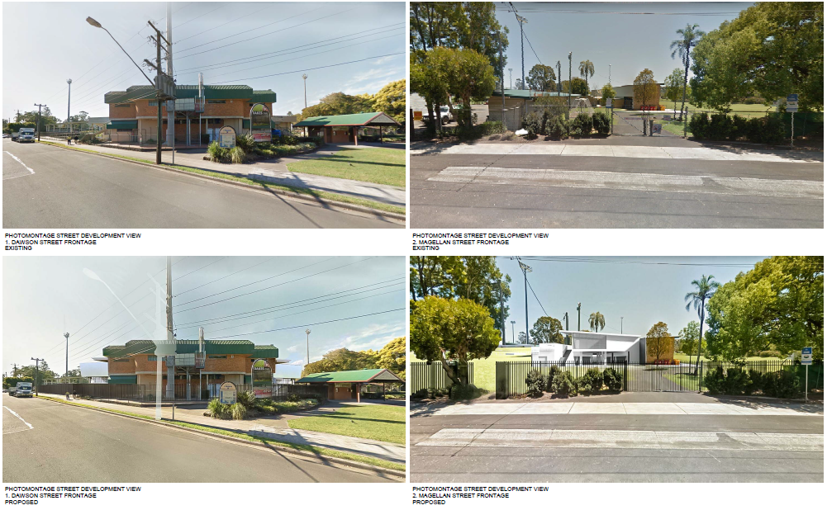

**Figure 7 – photomontage**

The proposal is not expected to generate any negative visual impact or privacy issues. Impacts such as overshadowing or the obscuring of important views or vistas are not likely, landscaping is being undertaken across the site as part of a separate planning approval process and will assist in further softening the appearance of the new structures when viewed from public areas and nearby residential land.

**11.3 Noise and amenity**

Possible disruption to residential amenity by way of noise, particularly to the low-density residential accommodation situated along Magallan Street, may occur. The use of the site as recreation facility has been in operation in excess of 20 years which has established certain expectations for the locality. However, along with the expansion and improvements to the facilities it is important to manage future events by implementing robust management instruments.

To have an overarching management document of the recreational facilities it is a requirement of consent that an Operational Management Plan (OMP) is submitted to and approved by Council prior to the issue of any Occupation Certificate. The OMP is to detail limitations such as patron capacity, hours of operations, noise emission, waste management, lighting and car parking and traffic control. The management plan is to be developed in accordance with applicable policies and in consultation with key event operators, the local community, Council’s Traffic Advisory Committee, Open Space and Reserves Team and other key agencies such as NSW Police and Transport for NSW.

The OMP is to establish suitable noise criteria based on the potential noise generated during events and private functions, including amplified music, announcements, traffic and crowds and to outline noise management measures, monitoring procedures, and processes for handling complaints.

**11.4 Traffic generation and car parking provision**

Possible Impacts in the locality that may occur include disruption to the road network and parking availability in the CBD during a large event.

The *Lismore Park Plan of Management* prepared by Lismore City Council and adopted 14 Jul 2009 identified that existing parking for the recreation facilities is ‘inadequate, undefined and in relatively poor condition’. With the upgrade of the recreation facilities will be improvements to the immediate road network via road widening and line marking (this has been included as a proposed condition of consent).

The adequacy of formalised car parking on site and in close proximity to the development, however, may even be reduced over time. As identified in the SEE Council is considering new land use and development opportunities upon the existing Harold Fredericks car parking facility, (located to the west of the site) which will remove parking availability. *Lismore Parklands Master Plan* also has a limited number of parking spaces proposed across the future parkland.

A Traffic Impact Assessment (TIA) prepared by Planit Engineering in 2017 (initially undertaken as a part of Review of Environmental Factors (REF) for the Oakes Oval redevelopment) was submitted with the proposed development. The TIA and the SEE have provided an assessment of the existing and post development capacity of the recreation facilities that concludes that the patron capacity does not significantly change as a result of the proposal and remains at approximately 10,000 patrons for Oakes Oval and 8,000 patrons for Crozier Field.

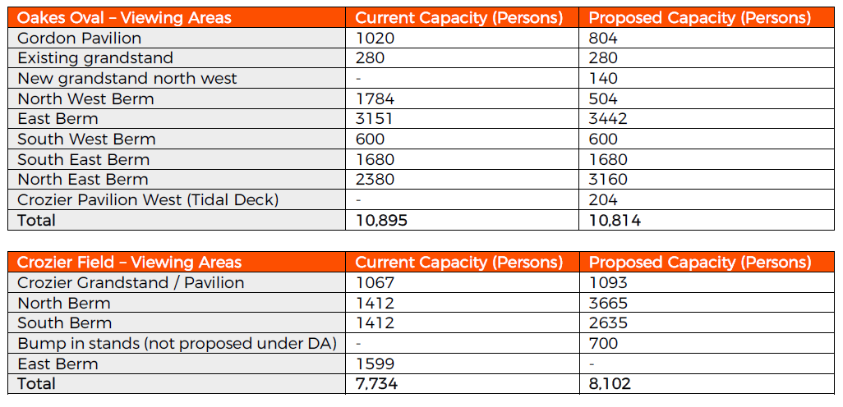

It is not considered that the proposed development is going to increase the net demand on car parking however, the proposed development is an opportunity to formalise event management processes via conditions of consent. Major events at either recreational facility have historically been governed through an Event Management Plan, which is reviewed by Council’s Traffic Advisory Committee and other events management staff and State emergency agencies to set limitations.

The TIA identifies that depending on timing of events and occupancy of the car parks, there are potentially 900 carparking spaces available in the vicinity of Oakes Oval. The two main carparks that will be utilised by Oakes Oval users are the Dawson Street/Magellan Street carpark and Dawson Street/Woodlark Street carpark. The total carparking spaces are as follows:

* Magellan Street carpark (Harold Fredericks car park): 307 carparking spaces
* Woodlark Street carpark: 270 carparking spaces

There is also opportunity for users of Oakes Oval to utilise on-street carparking along Dawson Street and Magellan Street which will yield an additional 323 carparking spaces. Additional parking would be available elsewhere in Lismore CBD within walking distance of the site. The TIA identifies that the typical car occupancy ranges between 2.5 and 3.0 persons per vehicle for sporting events and have concluded that the immediate locality can accommodate approximately 2,500 patrons (with 900 car parking spaces available).

To manage the impact on car parking demand and residential amenity in the locality it is proposed that major events (over 2,500 persons) at either recreational facility, is to have an Event Management Plan (EMP). The EMP is to demonstrate compliance with the OMP hours of operations, noise emission, waste management, lighting and crowd control and to include a Traffic Management Plan to be reviewed and endorsed by Council’s Traffic Advisory Committee. With a large proportion of the car parking being reliant on the existing Harold Fredericks car parking and the Woodlark Street carpark facility the Event Management Plan trigger of 2,500 persons or more is to be reduced taking into consideration the loss of car parking spaces. If one car park is lost the requirement trigger for an EMP is reduced by 3 persons. These details have been included as proposed conditions of consent.

Due to the fact the subject site does not provide or intend to provide for on site car parking, large events will be required to demonstrate that acceptable car parking can be provided. This may require securing the use of car parking locations offsite and using bus services to bring patrons to the venue.

To summarise, the following aspects of the proposed development have been identified regarding car parking;

* The recommendations provided by the TIA are to be adopted including that a Traffic Management Plan is prepared for large events (over 2,500 persons).
* Car park line marking improves the yield of the parking space by maximising the parking spaces available. A proposed condition of consent requires line marking to be undertaken in Magellan Street. Any additional works (road widening or kerb and gutter installation) required to facilitate the line marking will be undertaken as part of this consent.
* Management measures identified in the TIA are to be implemented such as;
  + both fields not be operational at the same time
  + large sporting events are to be undertaken outside of business hours such as on the weekends and after 5 pm
  + separate function centre areas are not be used during a sporting event for a non-related function
  + provide free charter buses from strategic locations with satellite parking outside the CBD
  + reduce car use by introducing paid parking for large events
  + encourage spending the night in (and parking at) accommodation in and around the CBD and walk to the event.

Council’s Traffic Advisory Committee and Development Engineers have reviewed the documentation regarding the proposed development and support the proposal and the implementation of theses management procedures.

**11.5 Stormwater**

Additional hard stand area will be created as a result of the additions to the Crozier Field Grandstand and the 140 seat grandstand. Council’s Development Engineers have advised that all stormwater from the proposed new structures can be directed into the Council stormwater network without causing any adverse impacts. The existing system can accommodate the additional flow.

The additional imperious area is predominately roofed area which in quality terms is low risk, however, it is considered important that the principles of Water Sensitive Design are incorporated into the overall design principles of the re-development. The proposed development triggers the provisions of *Chapter 22 – Water Sensitive Design Lismore Development Control Plan*, a condition has been nominated that requires the approval of a Section 68 of the *Local Government Act 1993* application demonstrating compliance with the requirements of *Lismore Development Control Plan – Chapter 22 – Water Sensitive Design (DCP)* and address all hard surfaces*.* The information submitted must include commentary that clearly demonstrates compliance with the DCP including predevelopment and post development calculations. A comprehensive Water Management Plan is to be developed and include maintenance and auditing/accountability systems.

**11.6 Accessibility**

Proposed conditions of consent require access to be provided for people with a disability in the Gordon Pavilion, Tidal Pavilion, Crozier Pavilion and the new grandstand in accordance with the *National Construction Code - Building Code of Australia Volume 1, 2019* and the *Disability (Access to Premises-Buildings) Standard-2010.*

The existing road network, including vehicular access, traffic impact and pedestrian safety, have all been assessed by Council’s development Engineer and Traffic Advisory Committee and have been deemed as acceptable.

**12. Suitability of the site for the development**

The land has been identified as being suitable for a recreation facility in regional and local strategic planning documents for many years and is consistent with the key actions in *Imagine Lismore 10 Year Plan (2013-2023)* and *Recreation Plan 2011-2021*.

The author concurs with the following sentiments contained within the SEE;

The site is suitable for the proposed development considering:

* the land is already developed and used as a recreation facility (major), comprising grandstands, multi-use area and playing fields. The maximum capacity for the site is not significantly changing as a result of the proposed works
* located on land and within a precinct which has a significant historical and cultural association with the playing and viewing of sporting events
* being located directly adjacent to the Lismore Park, providing synergies and efficiencies in open space and recreational opportunities on the fringe of the Lismore CBD
* the land has existing utility infrastructure connections which have capacity, or which can be augmented to provide capacity for, the servicing requirements of the proposed development
* the land is generally constraint free. Flooding is perceived to be the greatest environmental risk at the site, which has been determined to not be prohibitive for the project

**13. Notification/ Submissions**

The application was notified to adjoining and surrounding property owners and advertised in the *Lismore Local Matters* in accordance with the provisions of *Community Consultation Plan –* *Appendix 1 (Council’s Community Engagement Strategy and Community Participation Plan) for the Notification and Advertising of Development Applications*.

The exhibition period was undertaken 14 July 2020 to the 12 August 2020 and again 30 October 2020 to the 2 December 2020to readvertise the amended proposal undertaken as per clause 55(2) of the *Environmental Planning and Assessment Regulation 2000*.

As a result of the notification and advertising, 1 submission was received which are summarised as follows:

|  |  |  |
| --- | --- | --- |
| Name of Submitter | Summary of Issues Raised | Relevance |
| Peter Bellew | * Both facilities are under-utilised at present, it is against the public interest to spend $6.5m on facilities that are and will continue to be under-utilised. | A development application is not required to demonstrate that it will be suitably utilised or that a facility is currently being sufficiently utilised. The provision of sporting facilities has merit and is in the public interest. Sporting pursuits and facilities that support it are acknowledged as an asset for the community both socially and economically. |
| * The beautiful old wooden grandstands which gave Oakes oval its character and aesthetic charm should be returned. | The upgrade of the facility is to provide a facility that meets the current fire, flood, BCA and accessibility standards which old wooden grandstands no longer satisfy. |
| * The whole of this development is in deep flood prone land | See the section on flood in this report. |
| * Council is over $2m in debt and does not have the resources for the extra un-budgeted ongoing maintenance | This is not an assessment issue but a consideration for the developer. |
| * Has not received notification for previous developments | All LCC development applications are notified in accordance with *Environmental Planning and Assessment Regulation 2000* and *Council’s Community Engagement Strategy and Community Participation Plan*. |
| * Concerns over the possible removal of vegetation | Landscaping is being determined under a different planning pathway. Notwithstanding, no significant vegetation is proposed to be removed as a part of this development. |
| * The adopted Lismore Parklands Master Plan shows no expansion of Crozier Field | The proposed development is consistent with the adopted Lismore Parklands Master Plan |

14. Public interest

The proposal provides a high level of amenity through the provision of a modern regional sporting facility that achieves National Sporting requirements and is compliant with modern standards for accessibility, safety and security. The proposed development is in the public interest.

15. Conclusion

The provisions of Section 4.15 of the *Environmental Planning and Assessment Act 1979* have been satisfactorily addressed and assessed as acceptable. The application is recommended for approval subject to the imposition of appropriate conditions of development consent as set out in attached recommended conditions.

16. Recommendation

Pursuant to section 4.16/4.46 of the *Environmental Planning and Assessment Act 1979* (as amended) that the Northern Regional Planning Panel, as the consent authority, grant consent to Development Application No. 5.2020.247.1, subject to the conditions in *Attachment 1 - Draft Conditions of Consent*.

Mr C Bradridge - Town Planner (Development Assessment)

**Assessing Officer**